## **Write the python program to implement A* algorithm**

## **AIM**

To implement the **A* (A-Star) Search Algorithm** in Python to find the shortest path from a start node to a goal node using a heuristic function.

## **ALGORITHM**

1. Represent the graph as an adjacency list with edge costs.
2. Define a **heuristic function h(n)** estimating cost from each node to the goal.
3. Initialize an **open set (priority queue)** with the start node, storing (f, g, node, path) where:
   1. g = cost from start to current node
   2. f = g + h[node] = estimated total cost
4. Initialize a **visited set** to track explored nodes.
5. While the open set is not empty:
   1. Pop the node with the smallest f value.
   2. If it is the goal, return the path and cost.
   3. Otherwise, for each neighbor not visited, calculate new g and f and push to the open set.
6. Repeat until the goal node is reached.

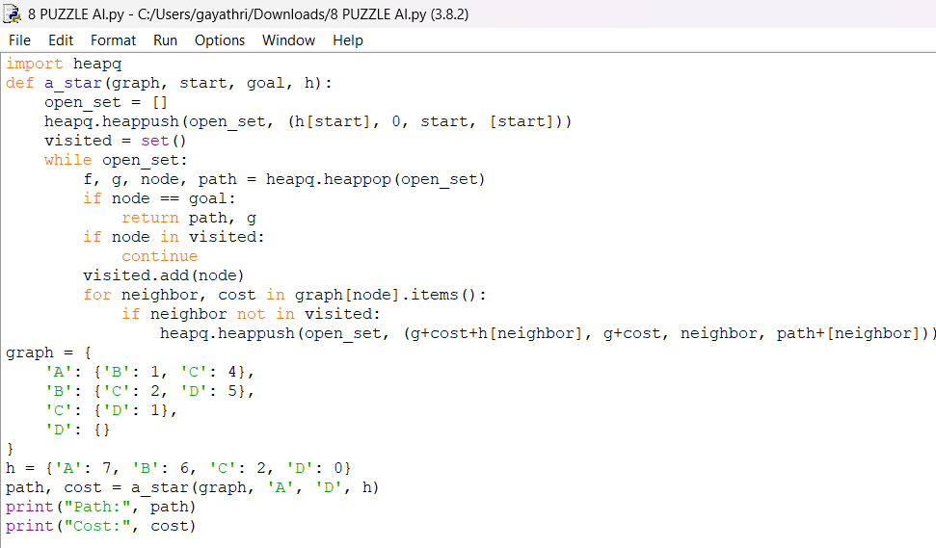

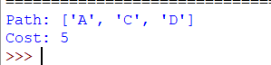

## **RESULT**

The program successfully found the shortest path from node 'A' to 'D' using A* search.